Object Oriented Software Design - CS2062

Group Project

Assignment 1

**Team 10 - Deck of Aces**

Akila Induranga (190239A)

Aruna Senanayake (190576D)

Bhanuja Sasanka (190152B)

Samadhi Divyanjalee (190159D)

**Project Description**

**Project Theme**:

To build a virtual library platform to facilitate the readers who have been stuck at home in this pandemic times.

**Description:**

Readers can subscribe to the platform, request books to read either by looking at the books available or by searching for a specific book. They can add books to their favorites list. Once a reader has finished reading a book, it will be added to his finished books list and he can view his favorites list, finished books list any time. Readers as well as the librarian can buy books for the library. Librarian can also add books to the library. System notifies readers to renew their subscription once a year. Reader can decide to renew or cancel the subscription. Readers also can request unavailable books. Those requests will be notified to the librarian once every week by the system.

**Assignment:**

Event table, use case diagram and activity diagrams for the above scenario are provided below.

**Event Table**

|  |  |  |  |  |  |
| --- | --- | --- | --- | --- | --- |
| Event | Trigger | Source | Use case | Response | Destination |
| reader wants to view the books list | request of books list | reader | get books list | books list | reader |
| reader wants to search a book | name of the book | reader | get the book | book | reader |
| reader wants to open a book to read | request of the book | reader | open the book | book | reader |
| reader wants to mark a book as read | request to finish | reader | close the book |  |  |
| reader wants to return a book without finishing | request to return | reader | close the book |  |  |
| reader wants to pay annual fee | card details | reader | pay fee |  |  |
| reader wants to cancel the subscription |  | reader | unsubscribe |  |  |
| reader wants to view the list of the books he read | request of profile | reader | get finished books list | books list | reader |
| reader/librarian wants to buy a book for library | book details, card details | reader/librarian | buy a book |  |  |
| librarian wants to add a new book | book details | librarian | add new book |  |  |
| system wants to notify the reader about unfinished books once every month | a month passes from last check | system | notify unfinished books | notification details | reader |
| system wants to notify a reader when his subscription expires (once every year) | a year passes from subscription paid | system | notify end of subscription | notification details | reader |
| reader wants to add a book to favorites list | book details | reader | add book to favorites |  |  |
| reader wants to view his favorites list | request of profile | reader | get favorites list | favorites list | reader |
| reader wants to request an unavailable book | book details | reader | add a new request |  |  |
| system checks for book requests once every month | a month passes from last check | system | notify requests | request details | librarian |

**Use Case Diagram**

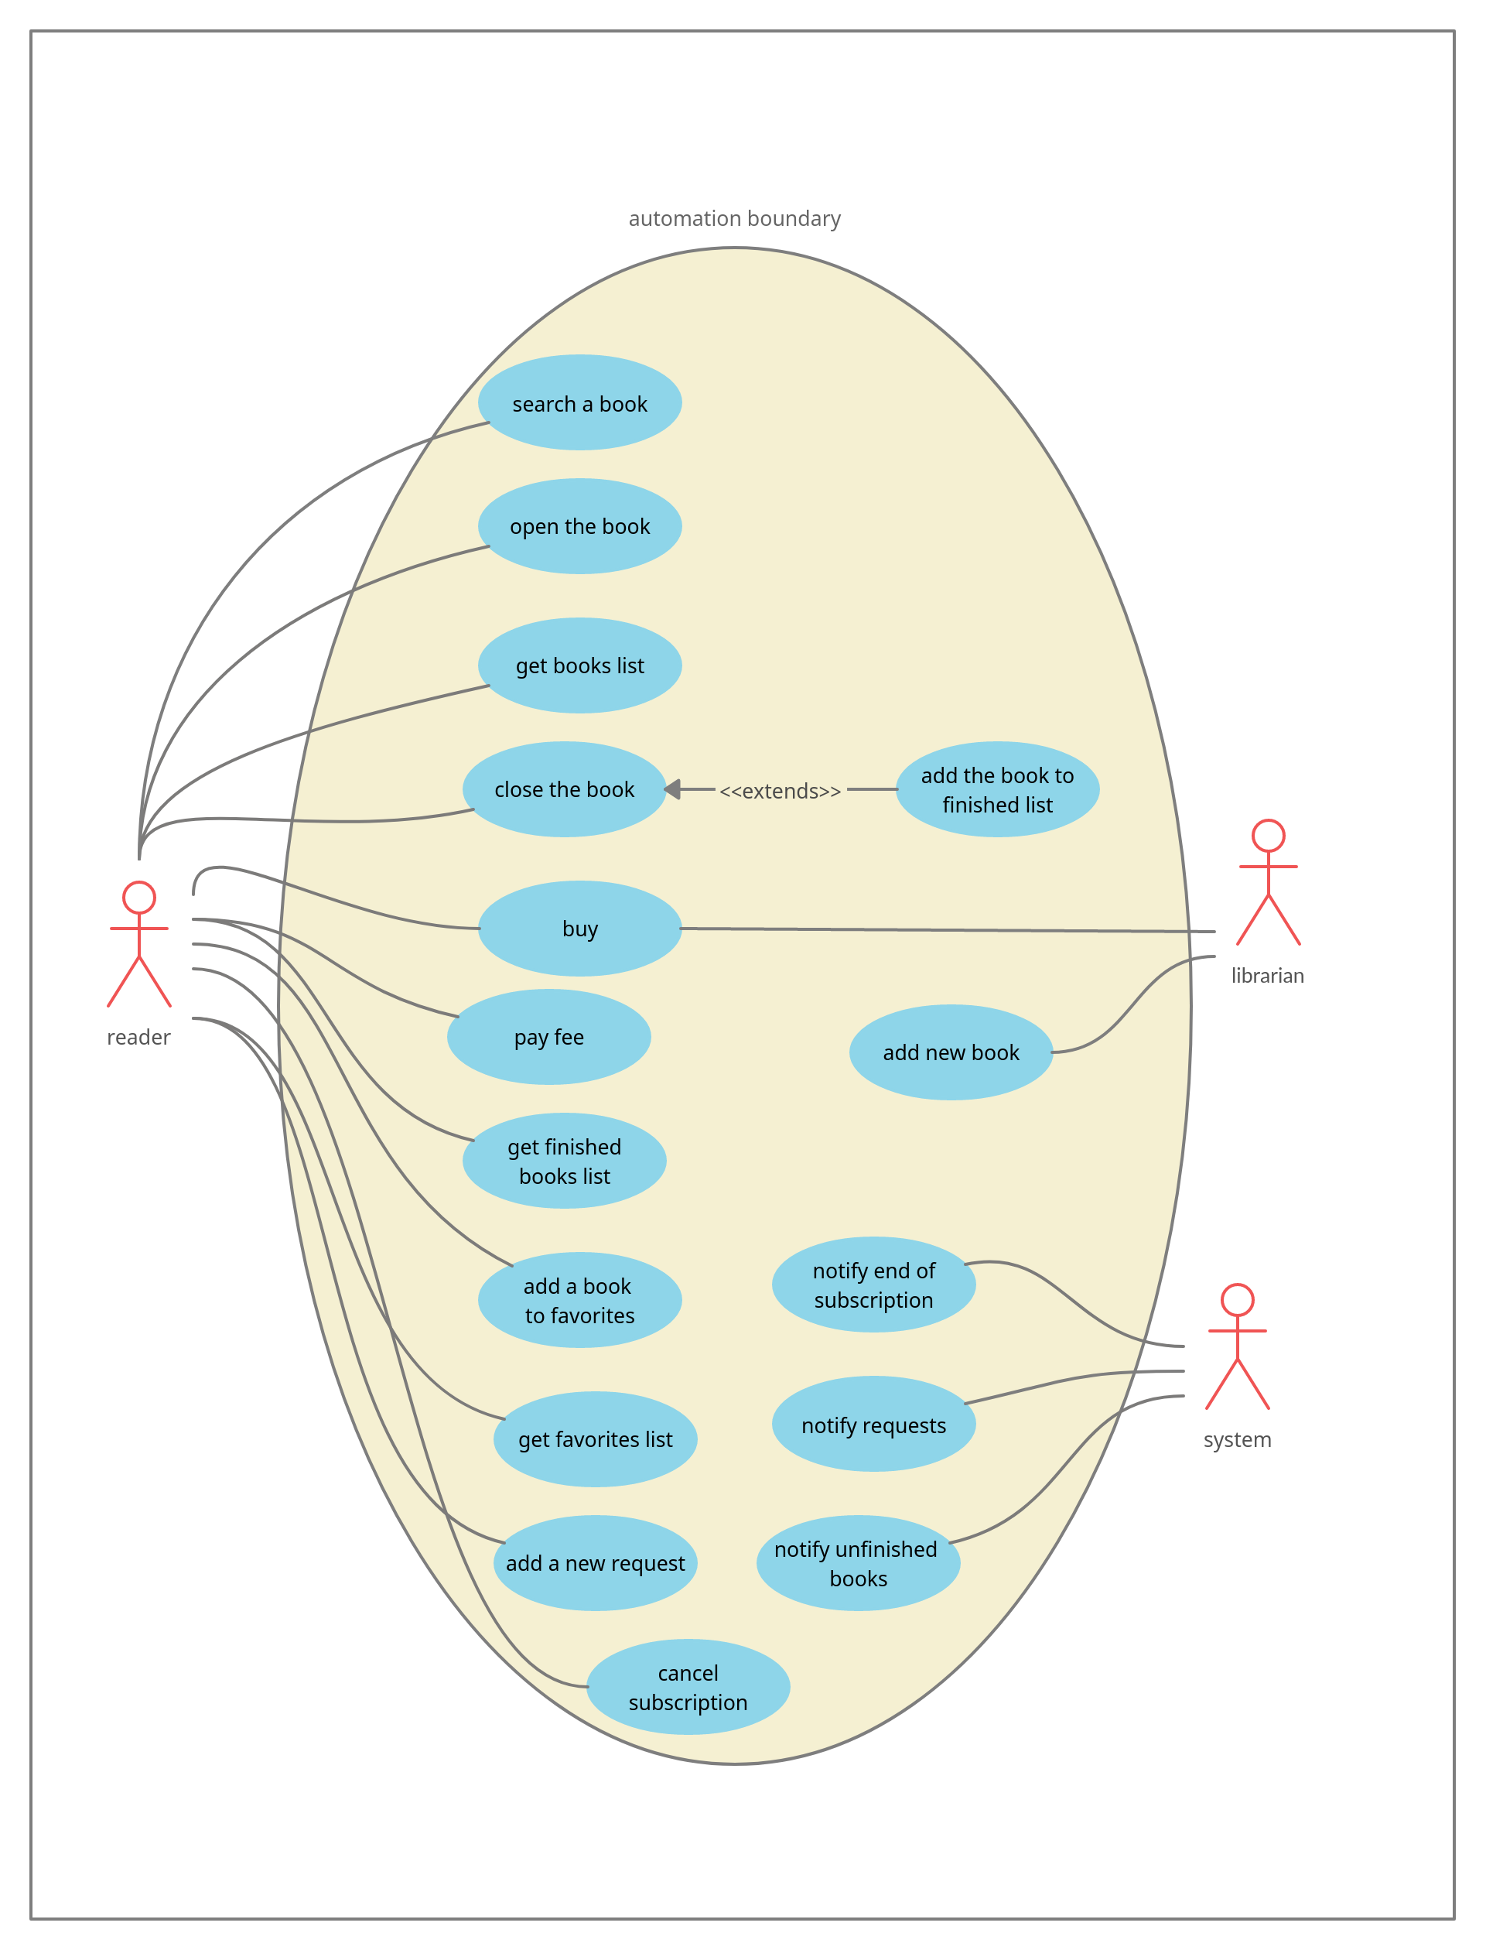

**Activity Diagrams**

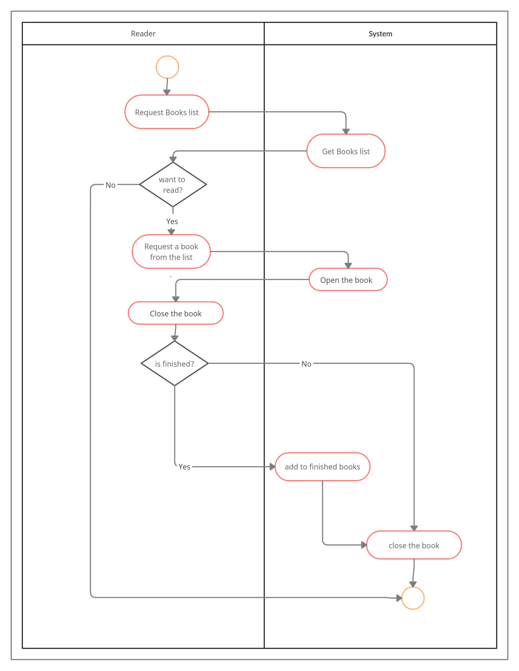By Akila

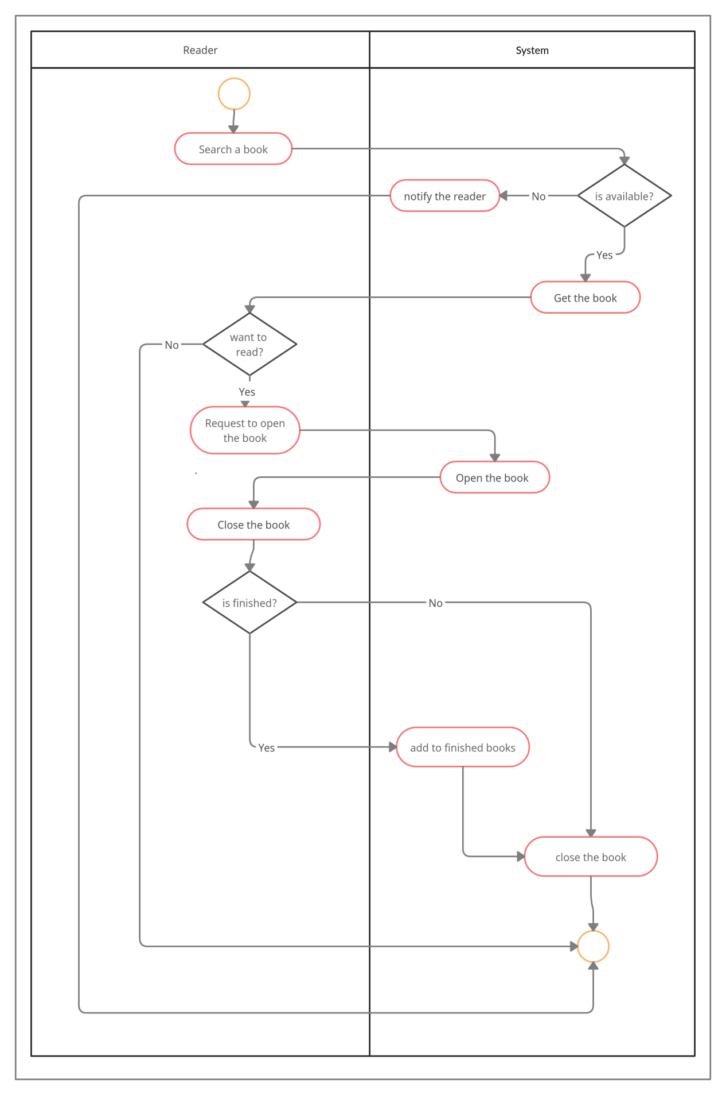By Akila

By Samadhi

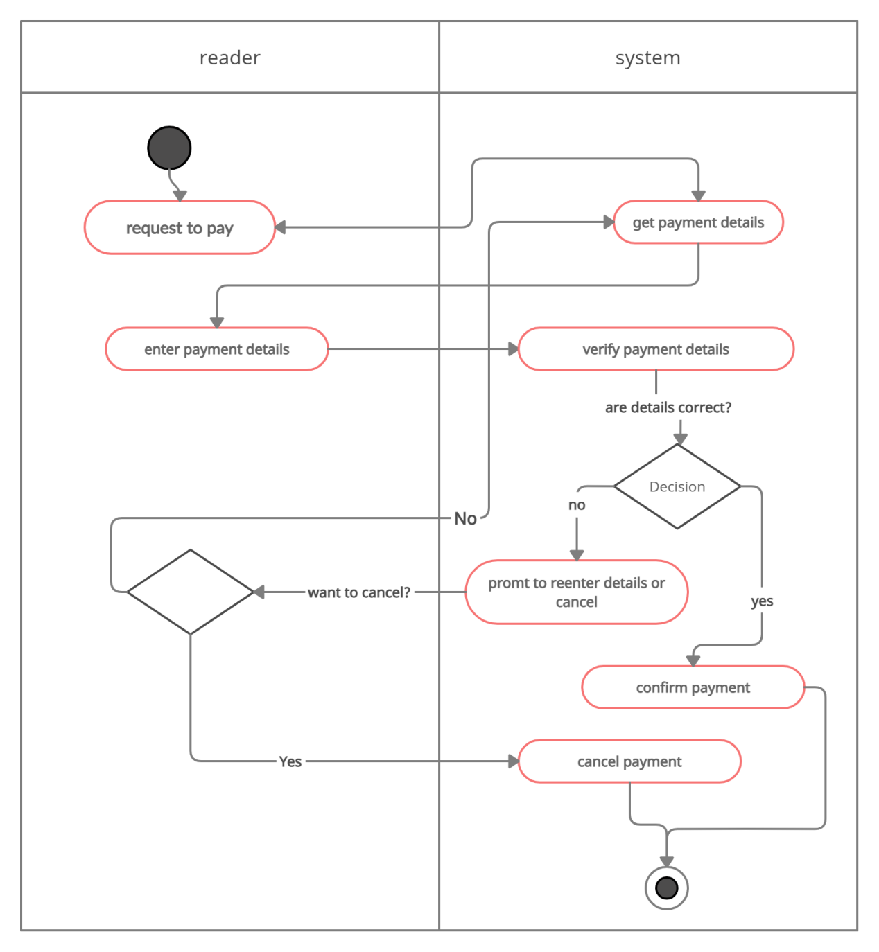

By Samadhi

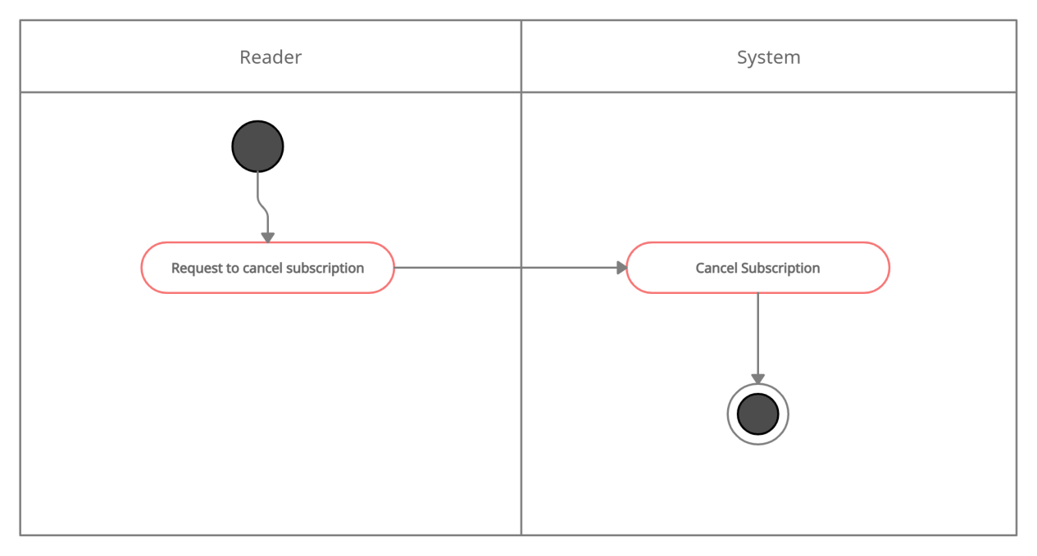

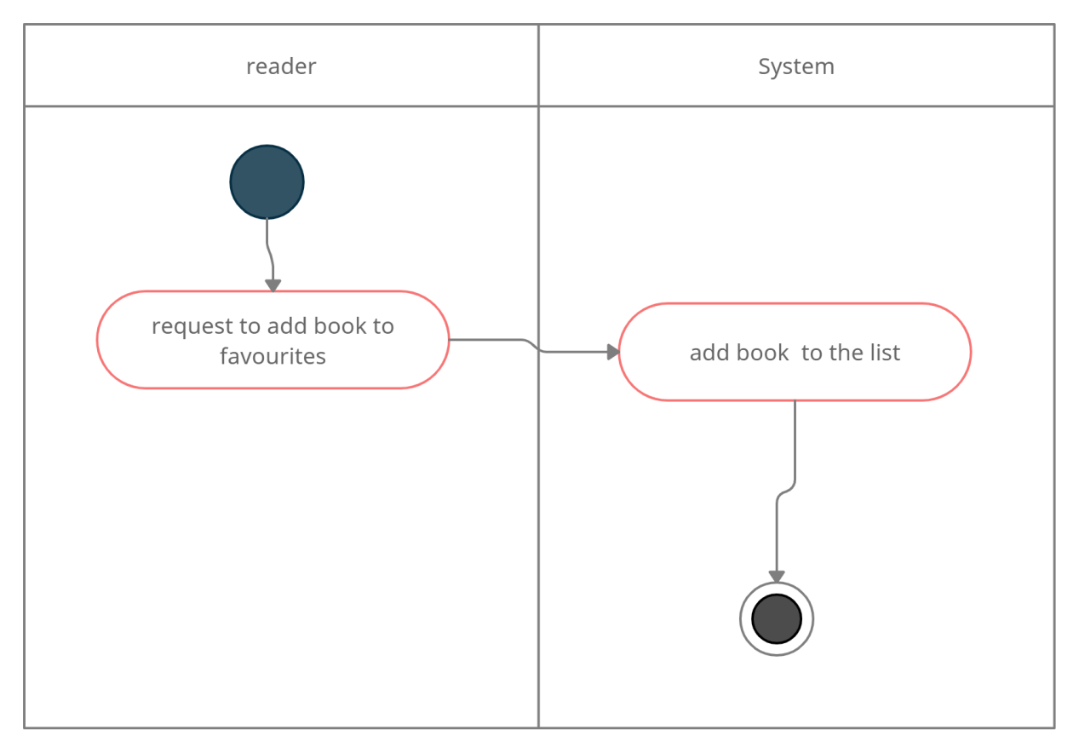By Samadhi

By Samadhi

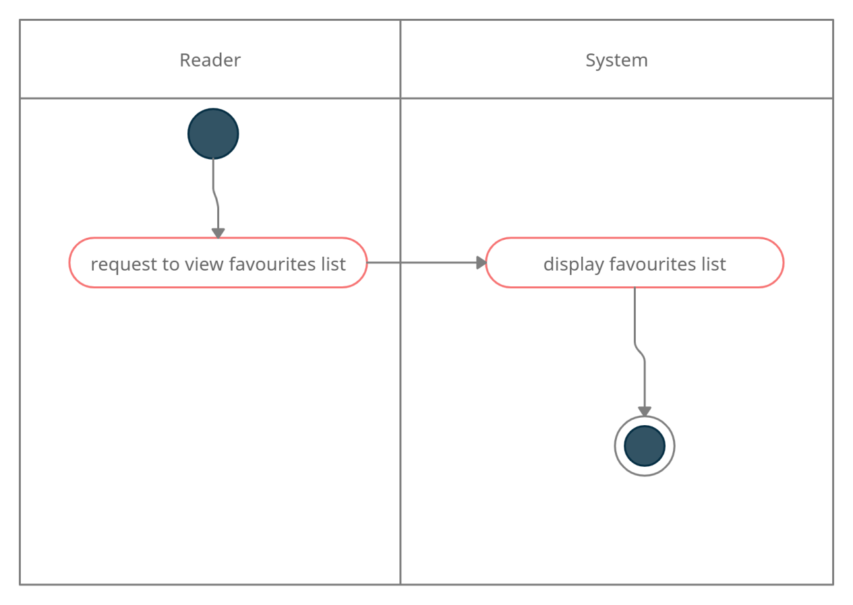

By Bhanuja

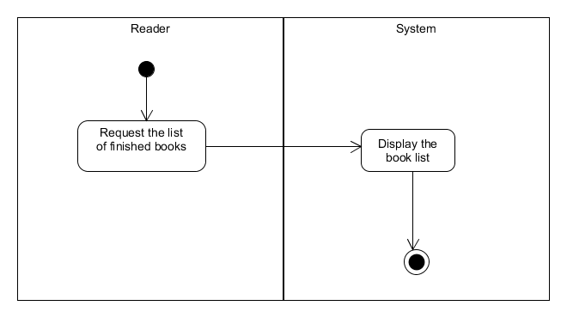

By Bhanuja

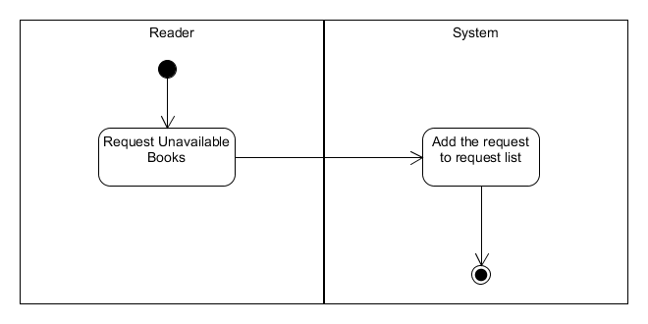

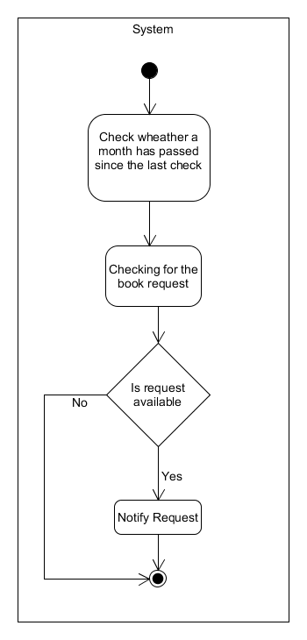

By Bhanuja

By Aruna

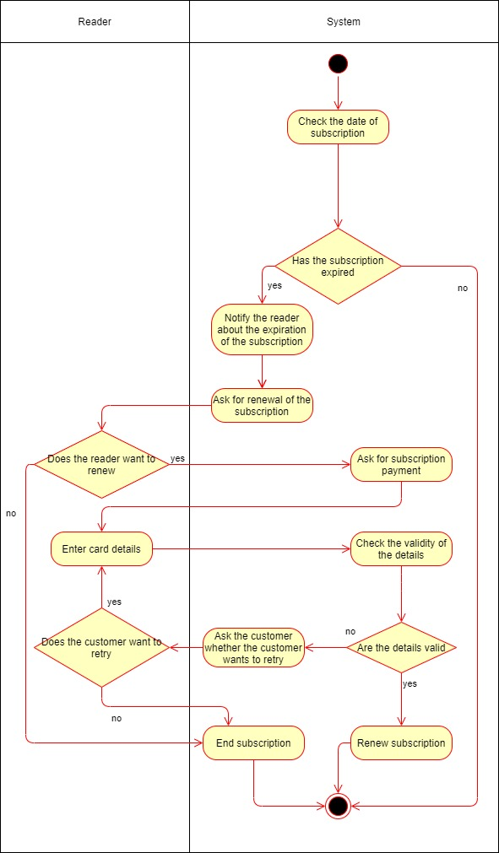

By Aruna

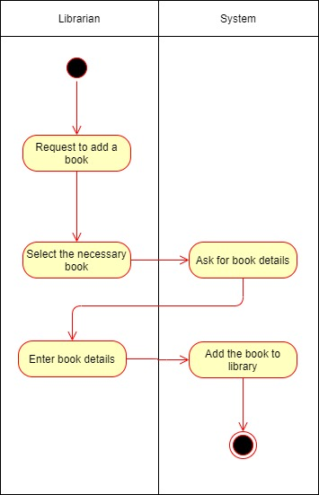

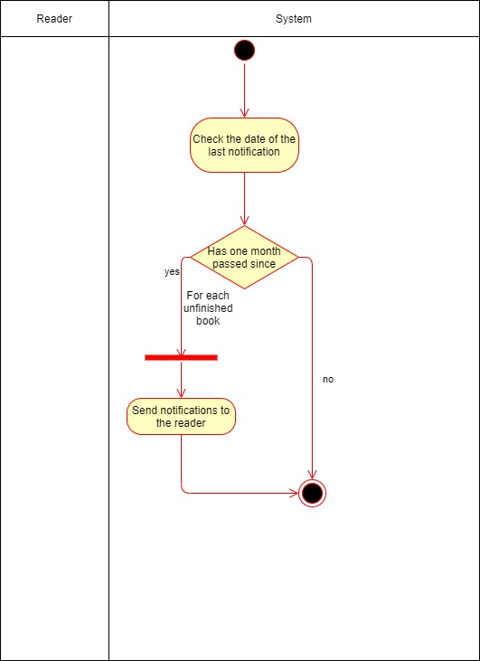By Aruna

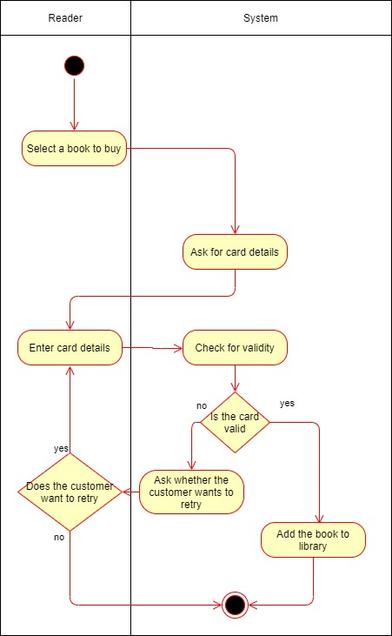By Aruna